What myStipend On-line Means To You?

In an effort to keep up with technology, we are now offering employees the ability to view their Stipend wage information on-line.

Benefits to the Employee/College:
- Reduced costs to the college – Each year Payroll receives several requests for explanations of stipends. This takes staff time. With this new online tool, staff will be able to access, print and view their Stipend wage information from any computer with an internet connection.
- Immediate access – Stipend wage information for the current month will be available for viewing four days prior to payday.
- Income Verification -Employees will be able to print copies of their Stipend wage information from a computer with an internet connection, allowing for faster income verification.
- Historical Income Information – Historical stipend information will be available.

Understandably, there are many questions that need to be answered. We have compiled a list of the most Frequently Asked Questions:
- What is a stipend? – Stipends are predominately used for payment contracts for part-time faculty. These contracts are also referred to as Assignment Contracts. In addition, stipends are also used for multiple reasons such as cell phone allowances, payroll adjustments, longevity payments, early retiree stipends, etc.
- Which staff will have wage information in their myStipend screen? Any person who receives a paycheck may have pay information in their myStipend screen.
- How Do I Sign up? – There is no need to sign up. If you have access to myClackamas, then you will be able to access myStipend.
- When will I be able to view my stipend wage information for the current month? For the current month’s pay, stipend wage information will be available for viewing four days prior to payday.
- How do I know how my pay for each class will be dispersed?
As a general rule, payments will be dispersed evenly over the number of months in which the class covers. You can use the information on the myStipend screen (see below) and your paystub (see below) to calculate how pay is disbursed. Example:
Class dates – 10/1/2009-12/12/2009;
Amount-$2,867.92
Pay dates – 10/30/2009, 11/30/2009, 1/4/2010
Pay Amount per month - $955.98
NOTE: Information in blue comes from myStipend Screen.
 | End Date | Description | Amount | Payments Made | Total Payments | Course Section Assignment
  Start Date
10/1/2009 | 12/12/2009 | MTH-095-05 | 2867.92 | 1 | 3 | MTH 095 05 Algebra III
10/1/2009 | 12/12/2009 | MTH-060-03 | 2867.92 | 1 | 3 | MTH 060 03 Algebra I
10/1/2009 | 12/12/2009 | Office Hours, AC | 588.06 | 1 | 3
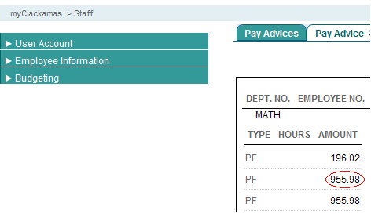 |  |  |  |  |  | 2867.92/3 = 955.98

- Will I be able to view stipend wage information from previous years? Yes. You will be able to view historical stipend wage information.
- How do I view and print my Stipend wage information? Follow these easy steps:
  - Access www.clackamas.edu
  - Click on myClackamas
  - Login using your email address and password
  - Within the myCougarTrax tab
  - Click on Employee Information
  - Click on myStipend
  - Click on the month you would like to view
  - Select File and Print

Questions: Please contact Vicki Hedges at 503.594.3087 or Michelle Dodgion at 503.594.3092.

